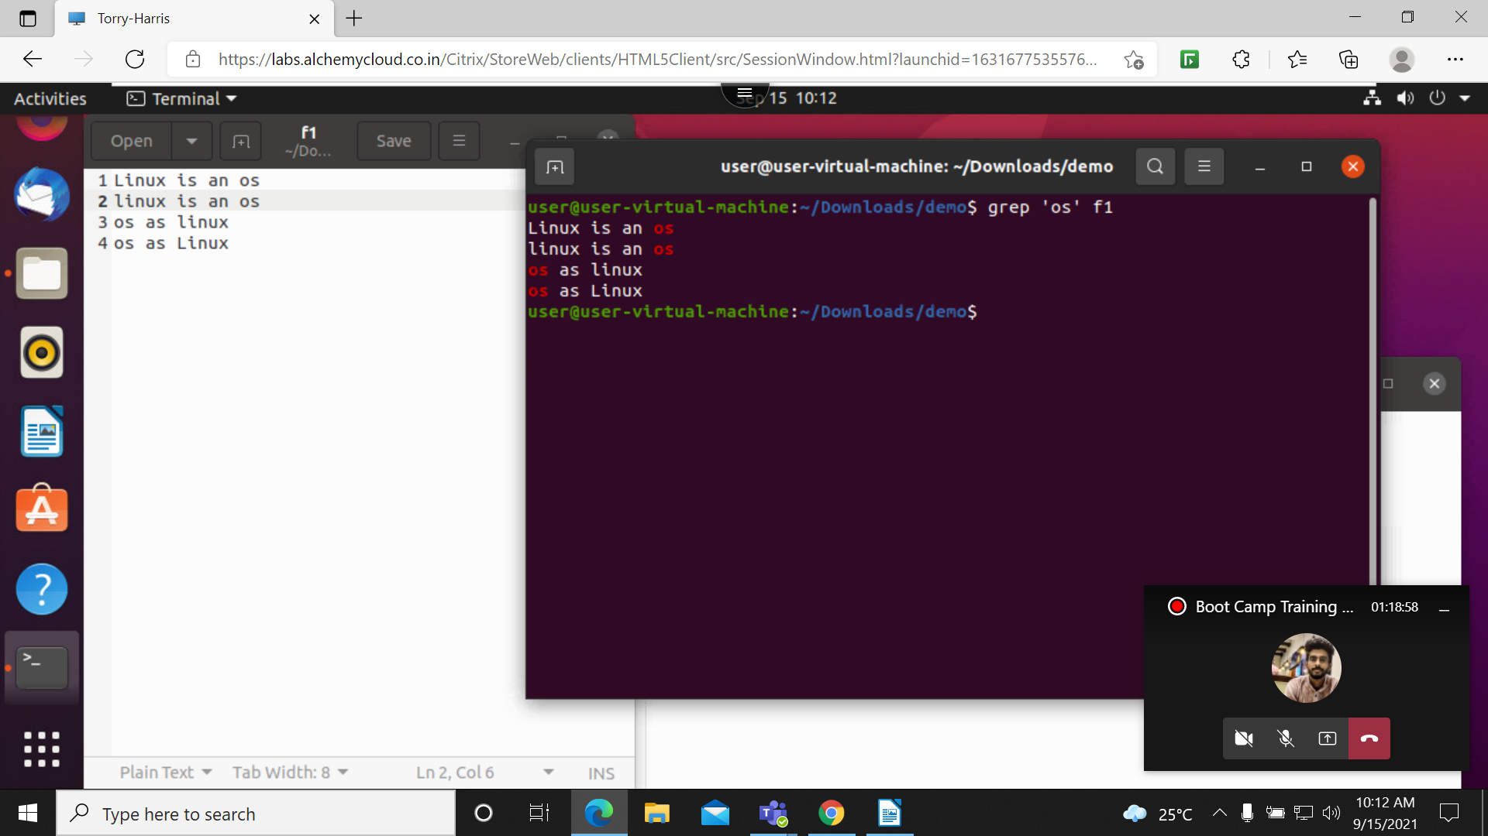
- Grep: is use to search the file for particular pattern of a character

2. grep -i: use to ignore the case-sensitive
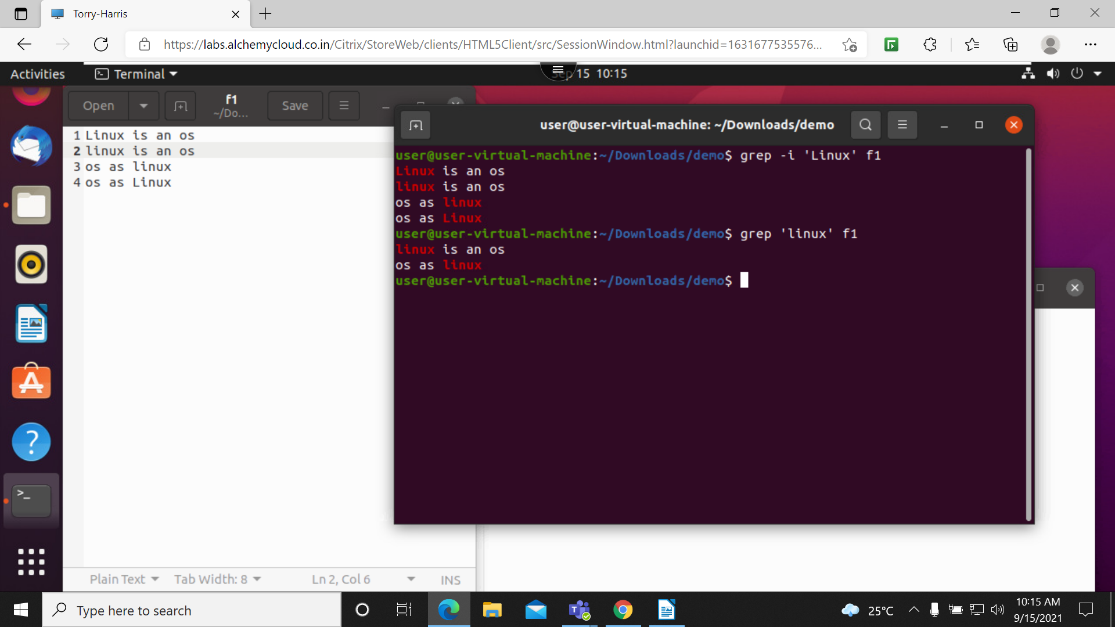

3. grep -c: it will give the count of a string or character present in a file
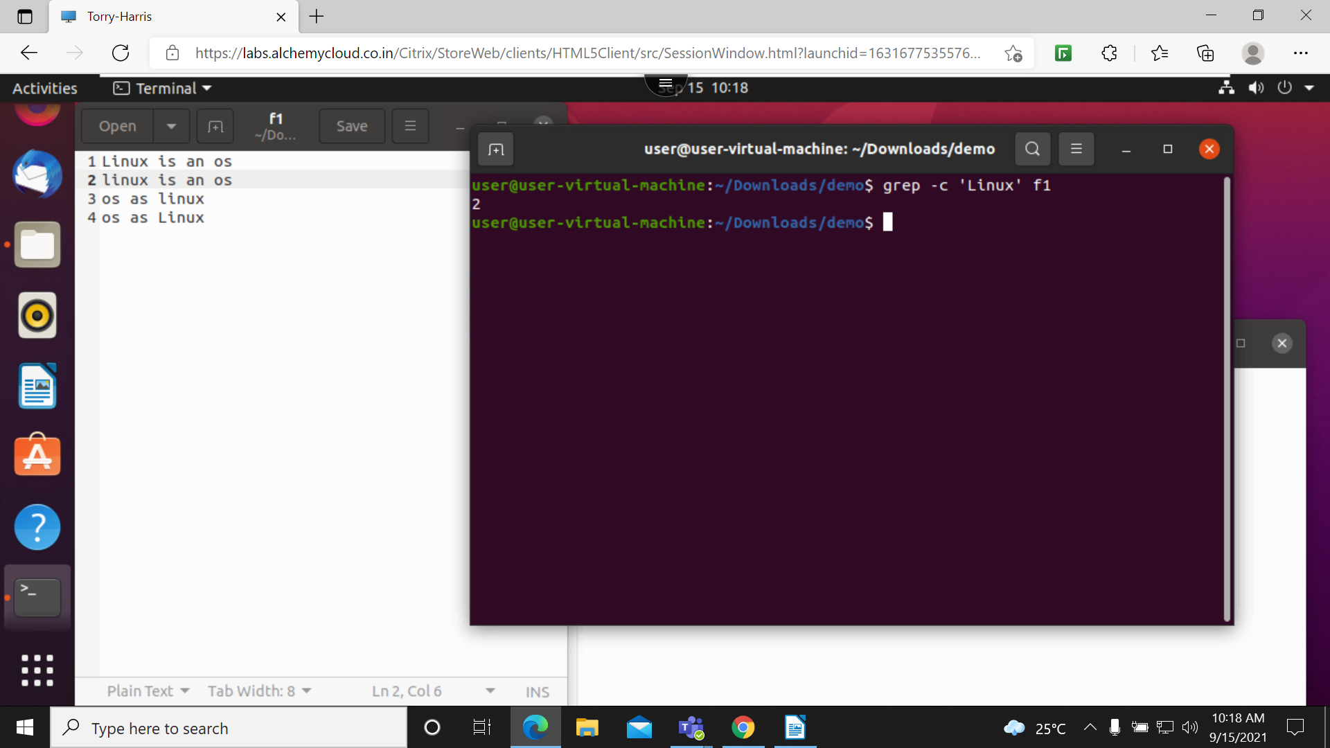

4. grep -c -i: it will ignore the case sensitive and it will give the count of string
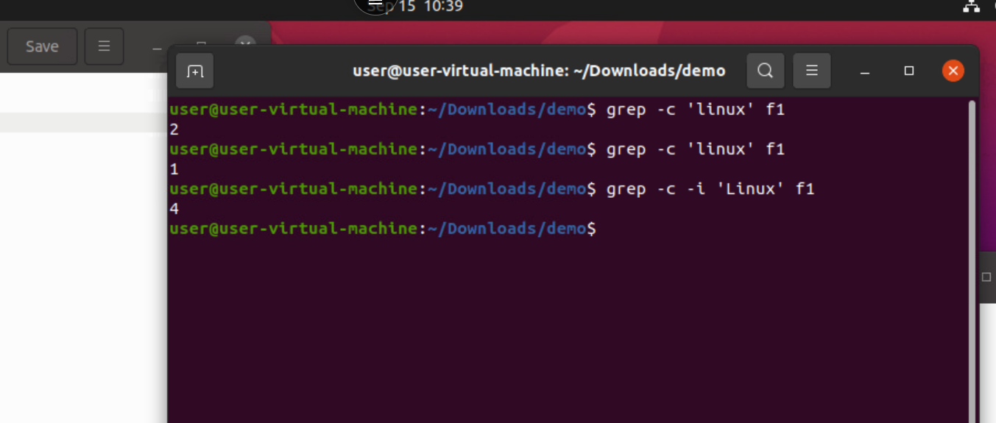

5. grep -l: it will shows all the directory and text files which contain in the folder

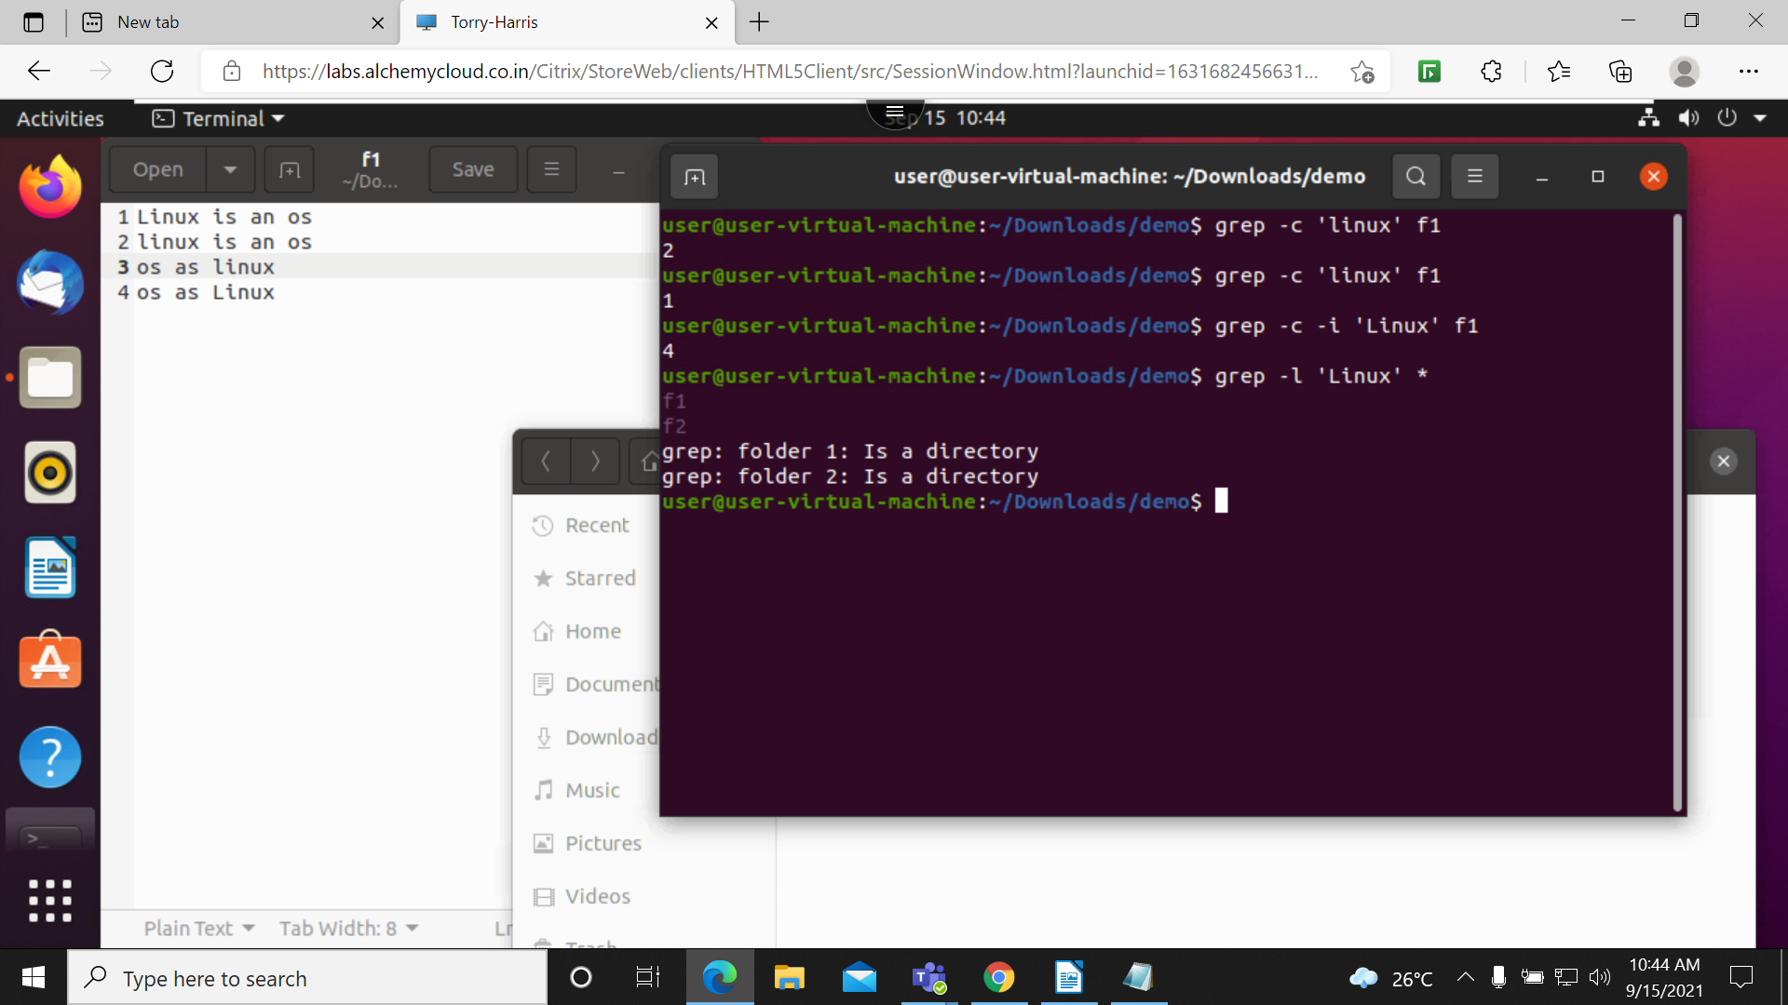

6. grep -w: use ignore the sub string of an a string
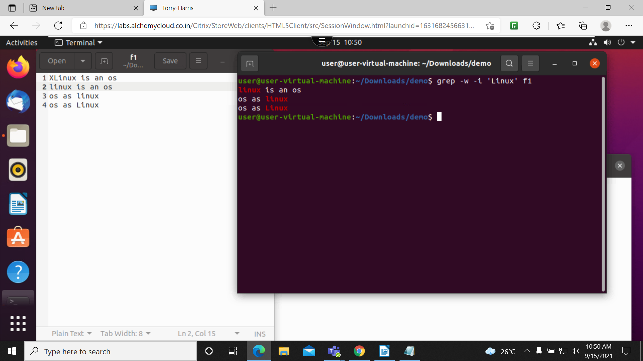

7. grep o: it will print matching pattern of the string not sub string and not a whole string
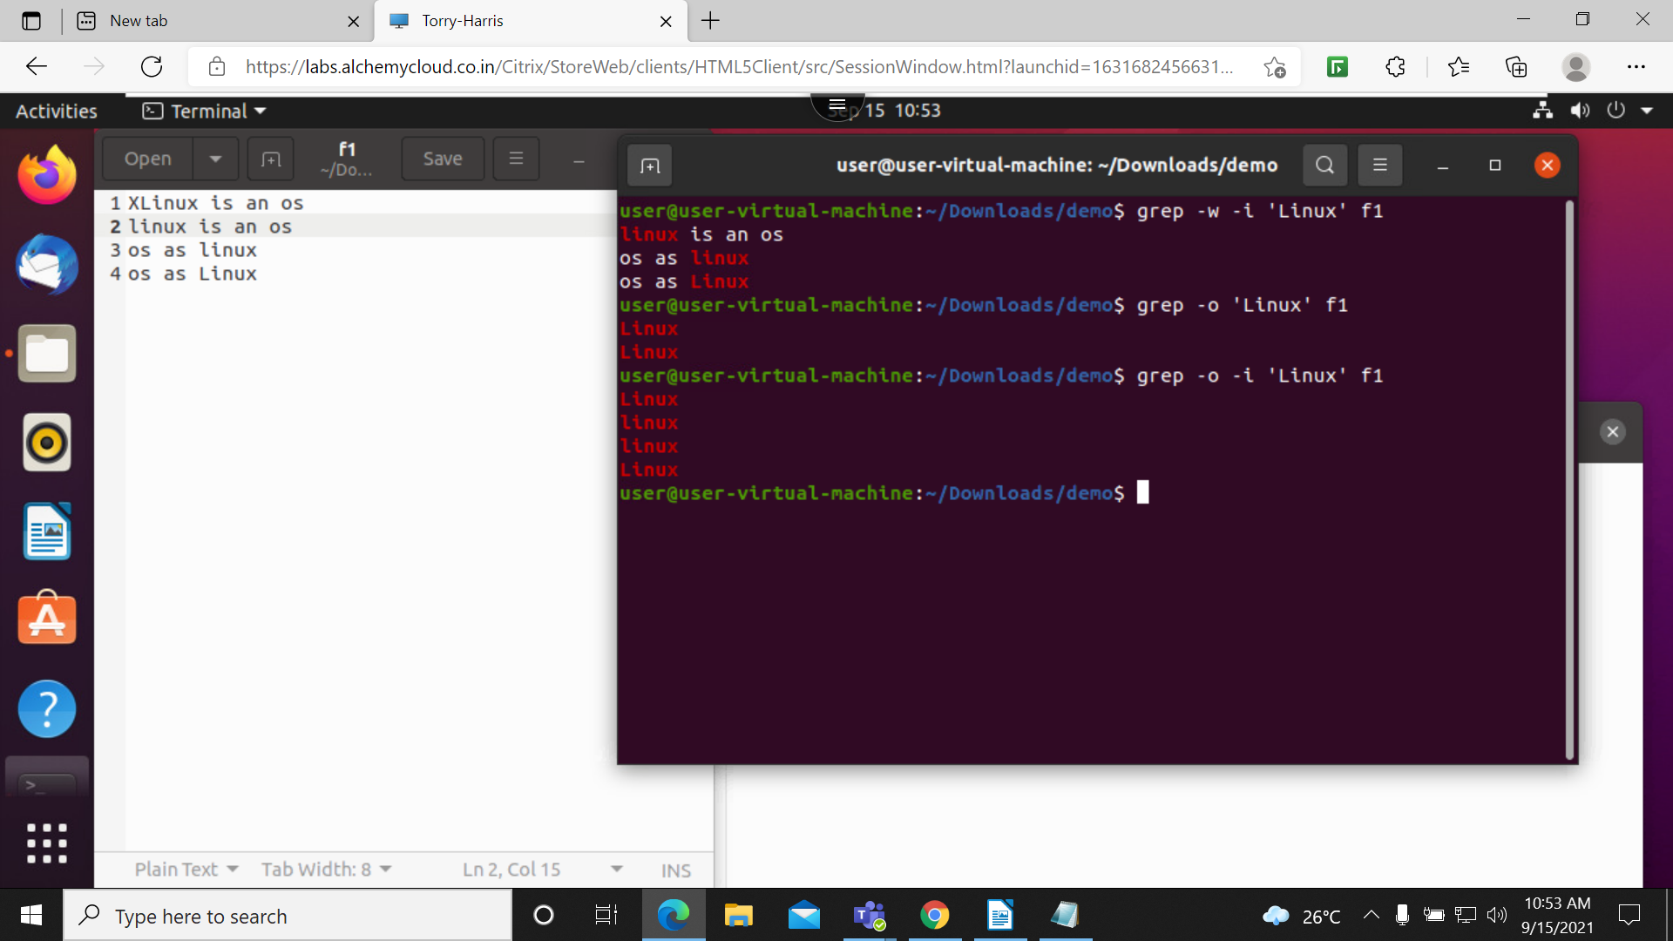

8. grep -oiw: this will print matching pattern and ignore case sensitive and it will not print sub string
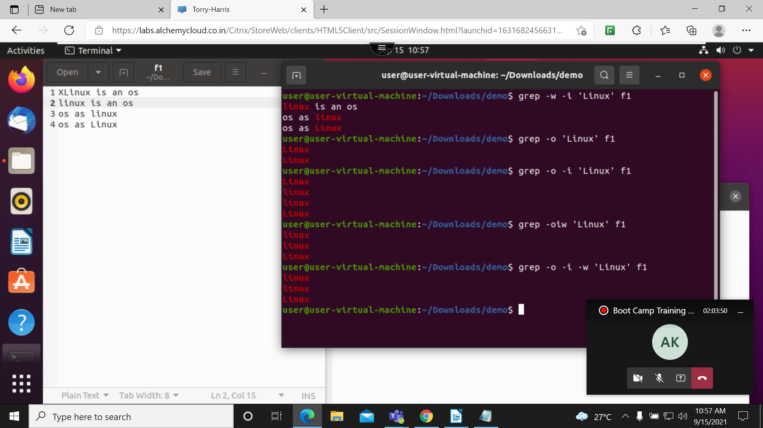

9. grep -n: it will show the line number of the string
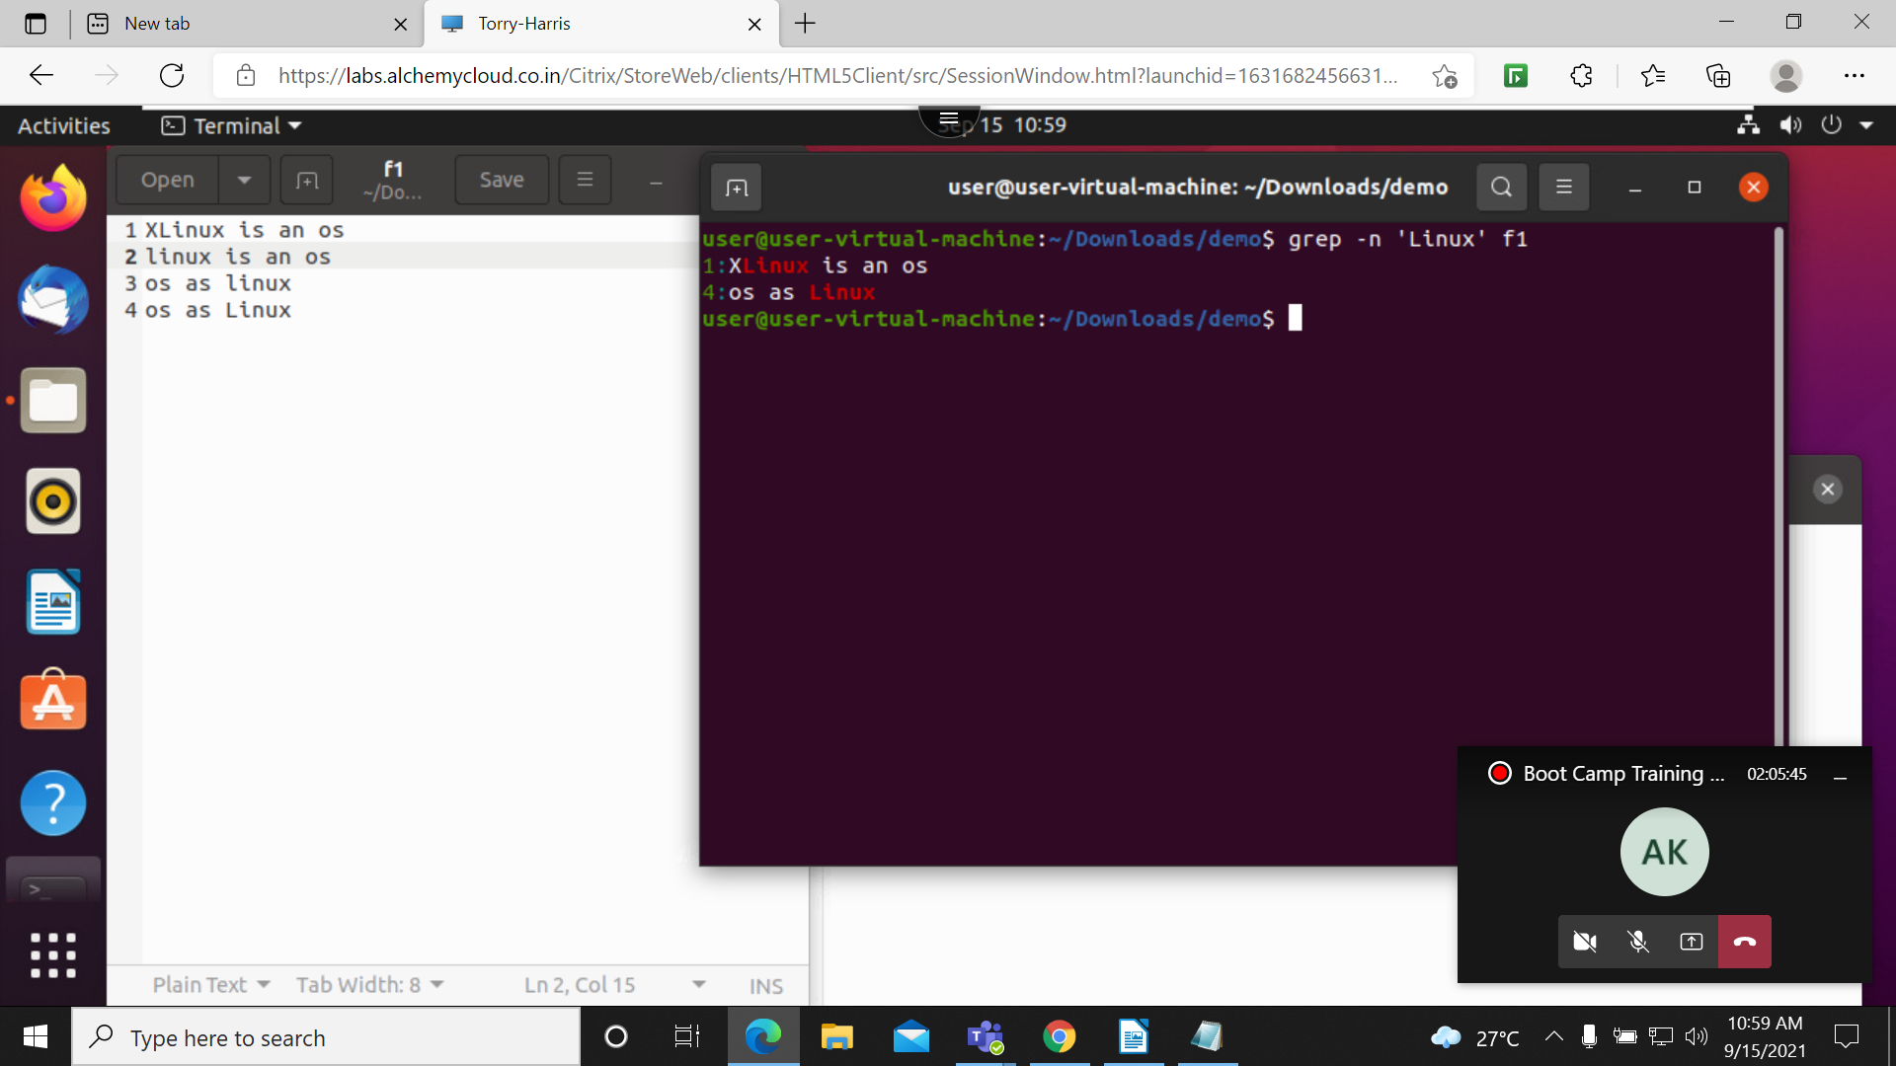

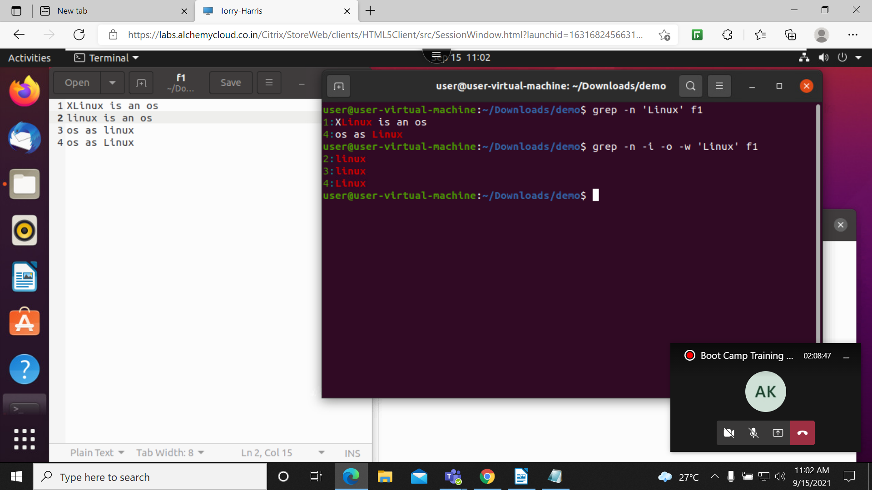
10. grep -noiw: this will print line number of the string and ignore the case sensitive and prints the matching pattern

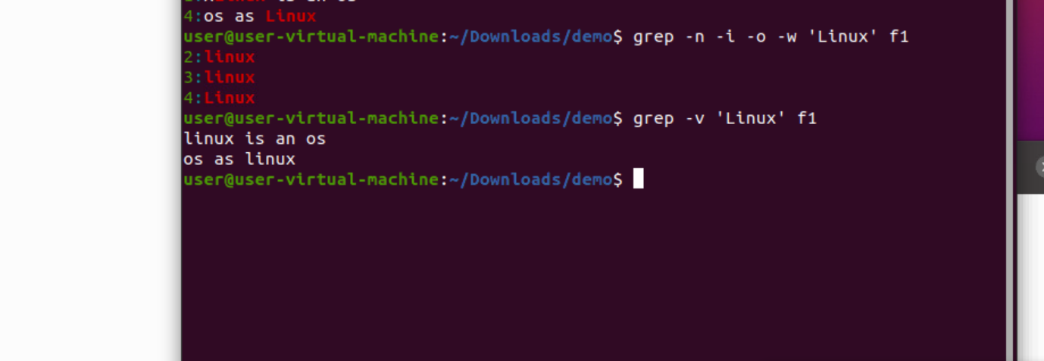
11. grep -v: it will print small case sensitive of a string and whole string in a file

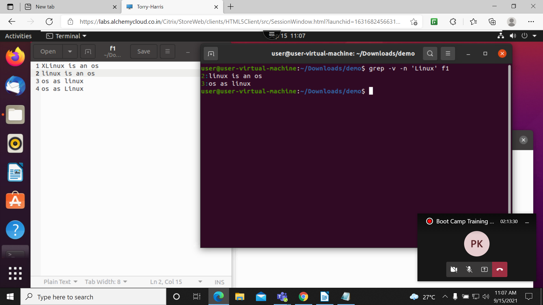
12. grep -v -n: will print whole pattern and line numbers

13. grep -i ‘^os’ f1: this will print staring string with linux
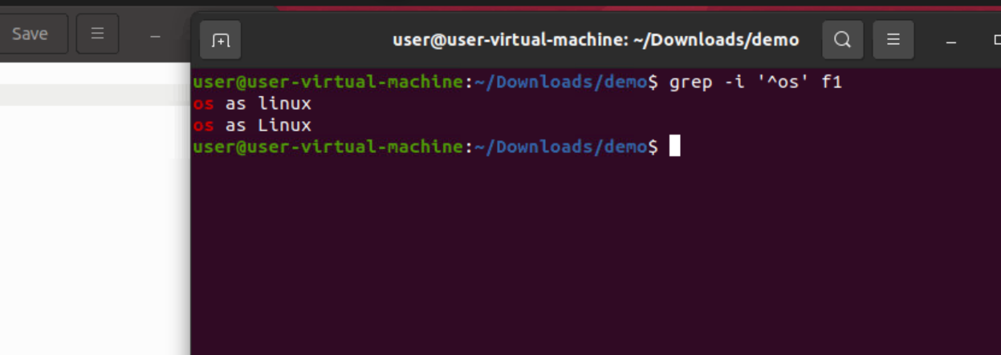

14. grep -n -i ‘^os’: this print line number which staring from string
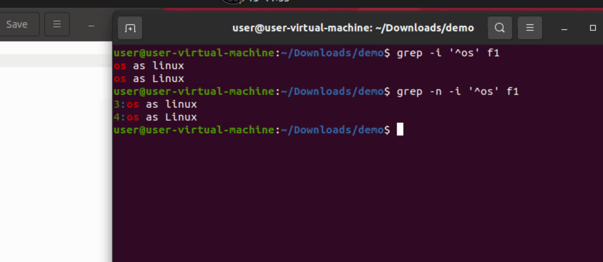

15. grep -i ‘os$’: this print the string which is ending with the os
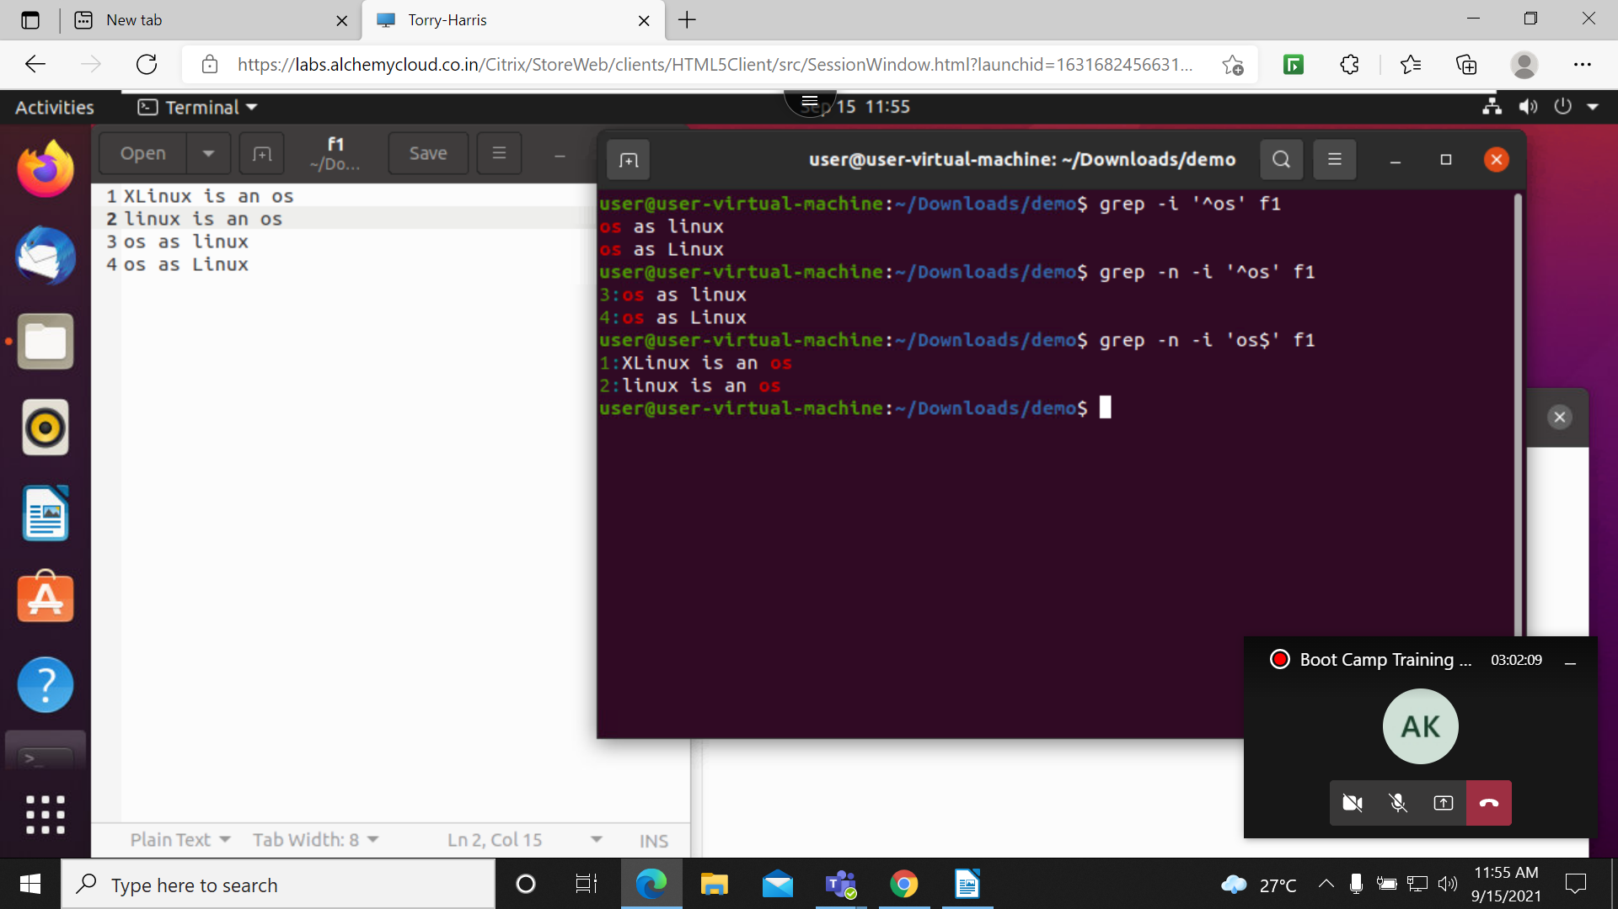

16. grep -i ‘^os .* os$: this will print both ending staring of the string
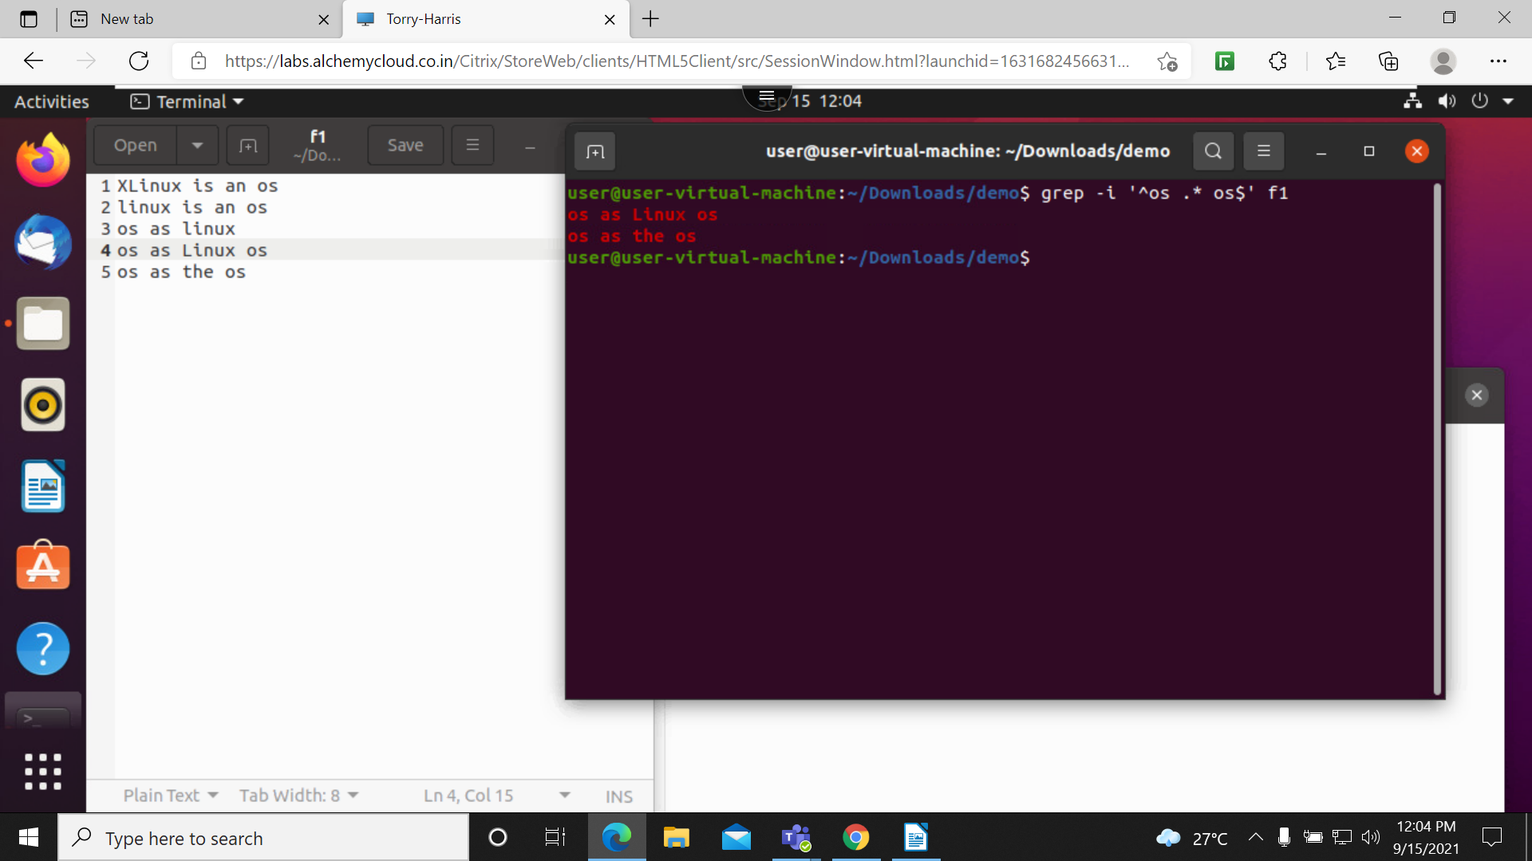

17. grep -n -i – E ‘^h.p$: this will print the string which is starting from h and ending from p with character space one
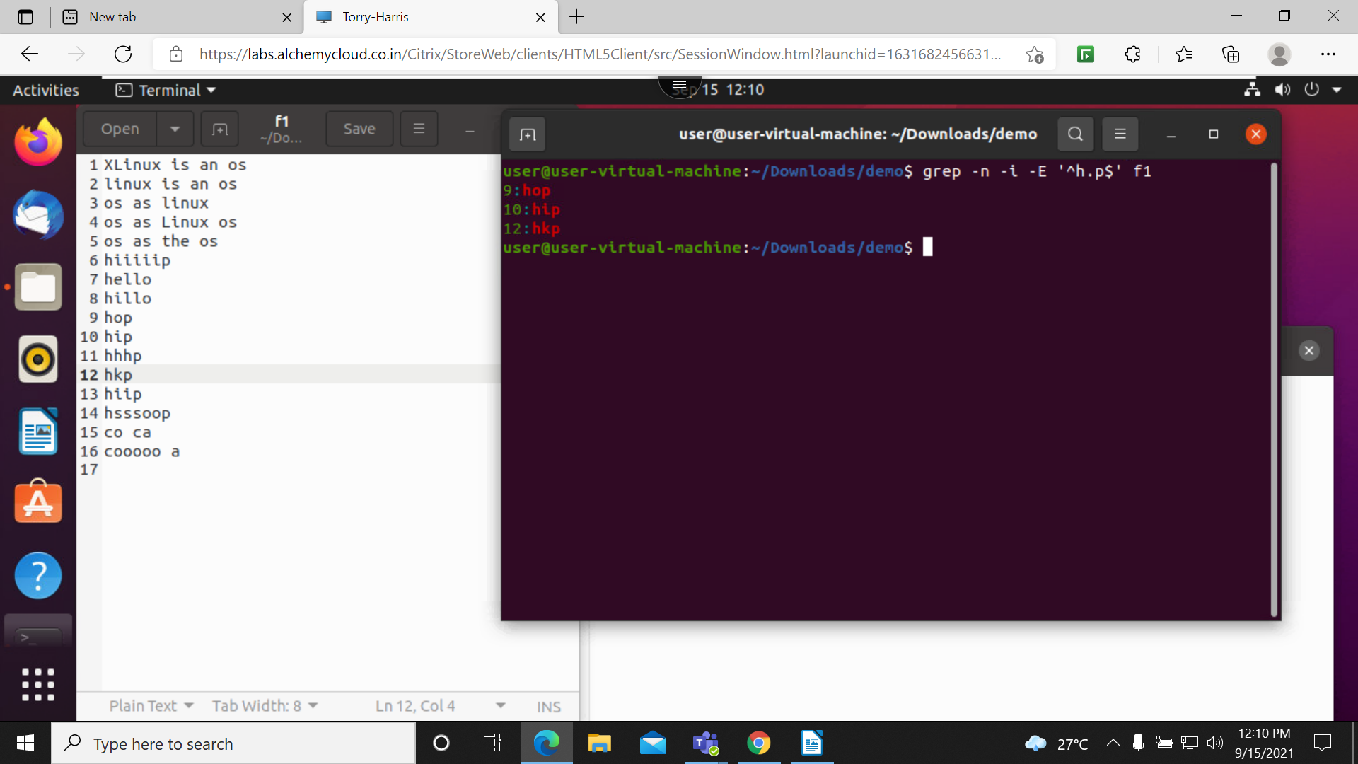

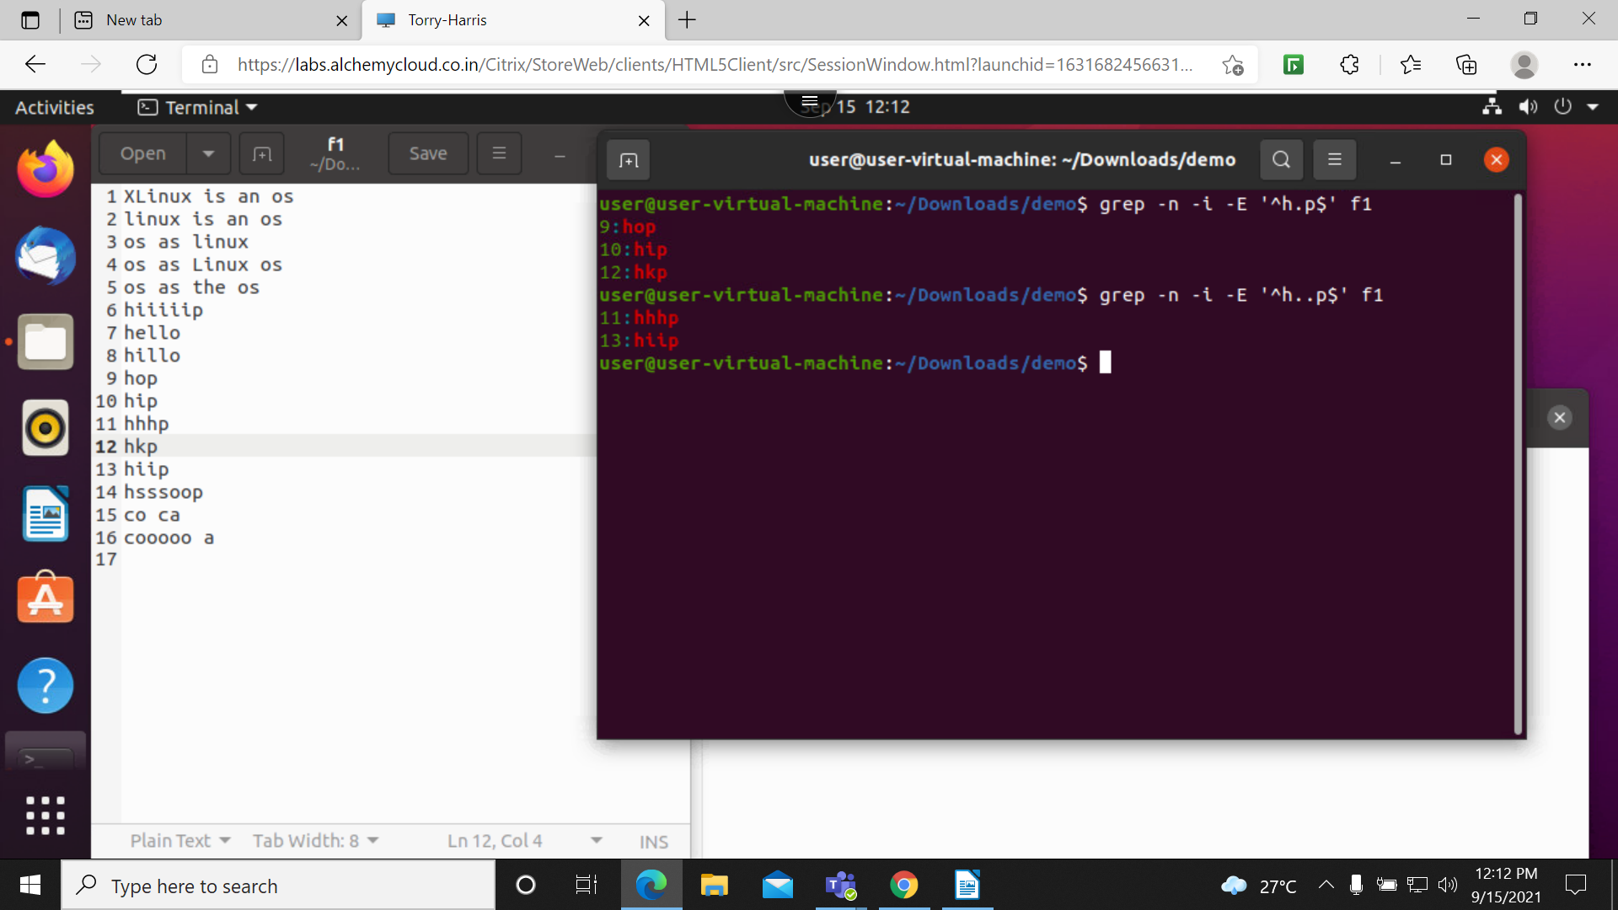
18. grep -n -i -E ‘^h..P$: this will print the string from h and ends from p with 2 character space in between string

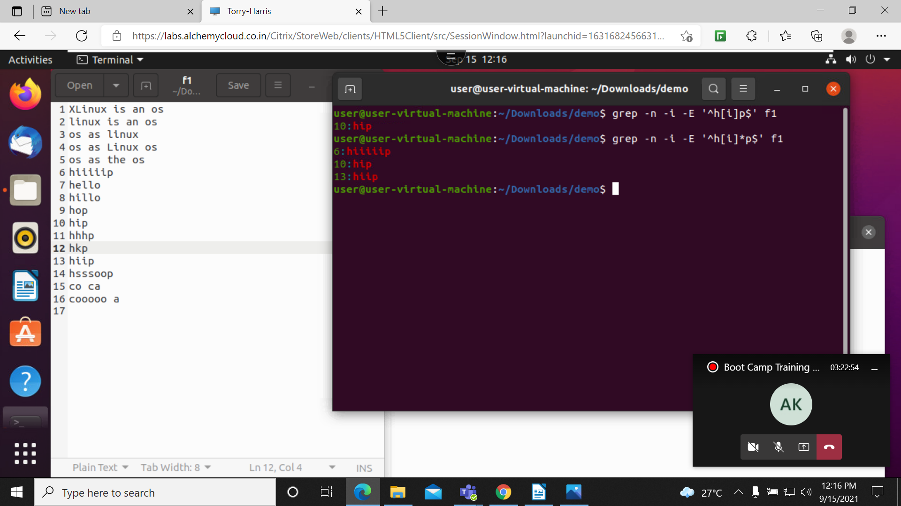
19. grep -n -i -E ‘^h[i]p$: this will print the occurrence of I in the 2nd string either one or more occurrences

20. grep -n -i -E ‘^h.*p$: this will print all the strings which is start from h to p
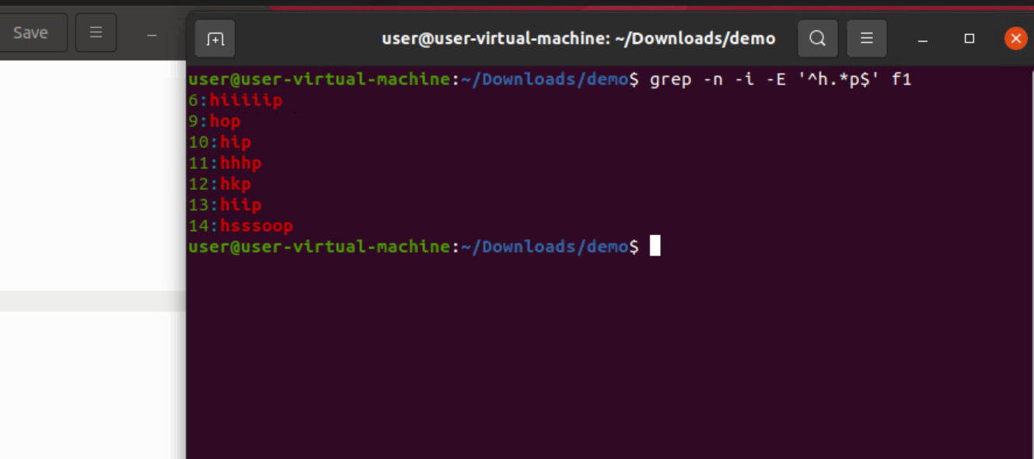

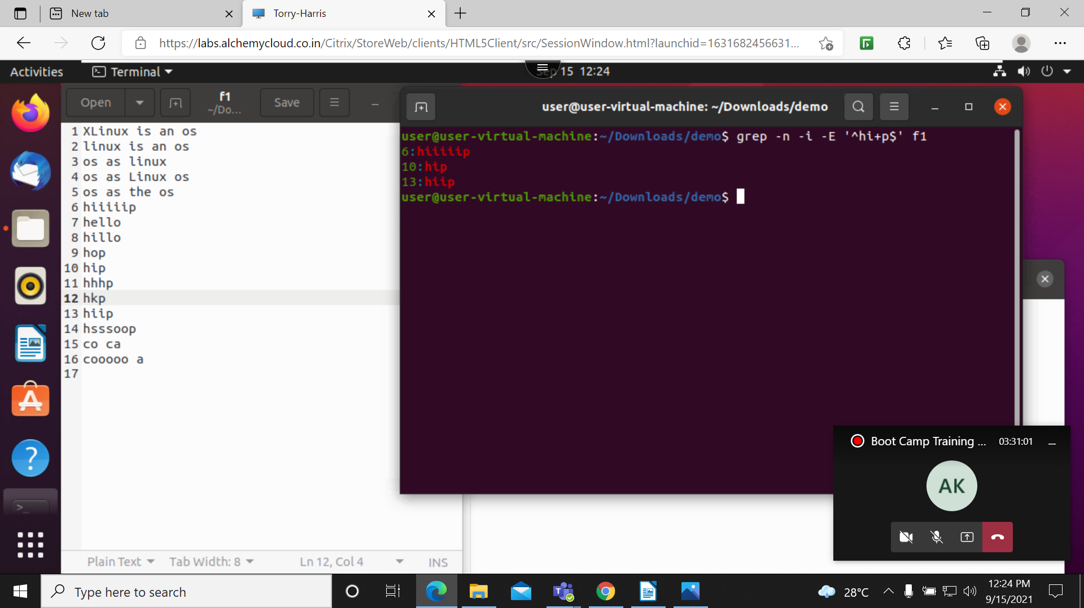
21. grep -n -i -e ‘^hi+p$’: it will print all the strings which is having string starting from h top in between I

22. grep -n -i -E ‘^h[i]+p$: it will print all n number I character in between string
23. grep -n -i -E ‘^h[el]+o$: this will print all the string which contain el in between the string
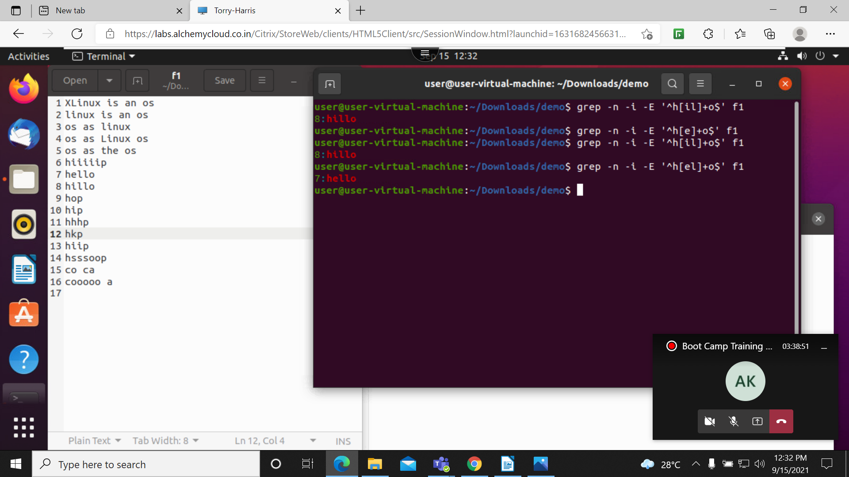

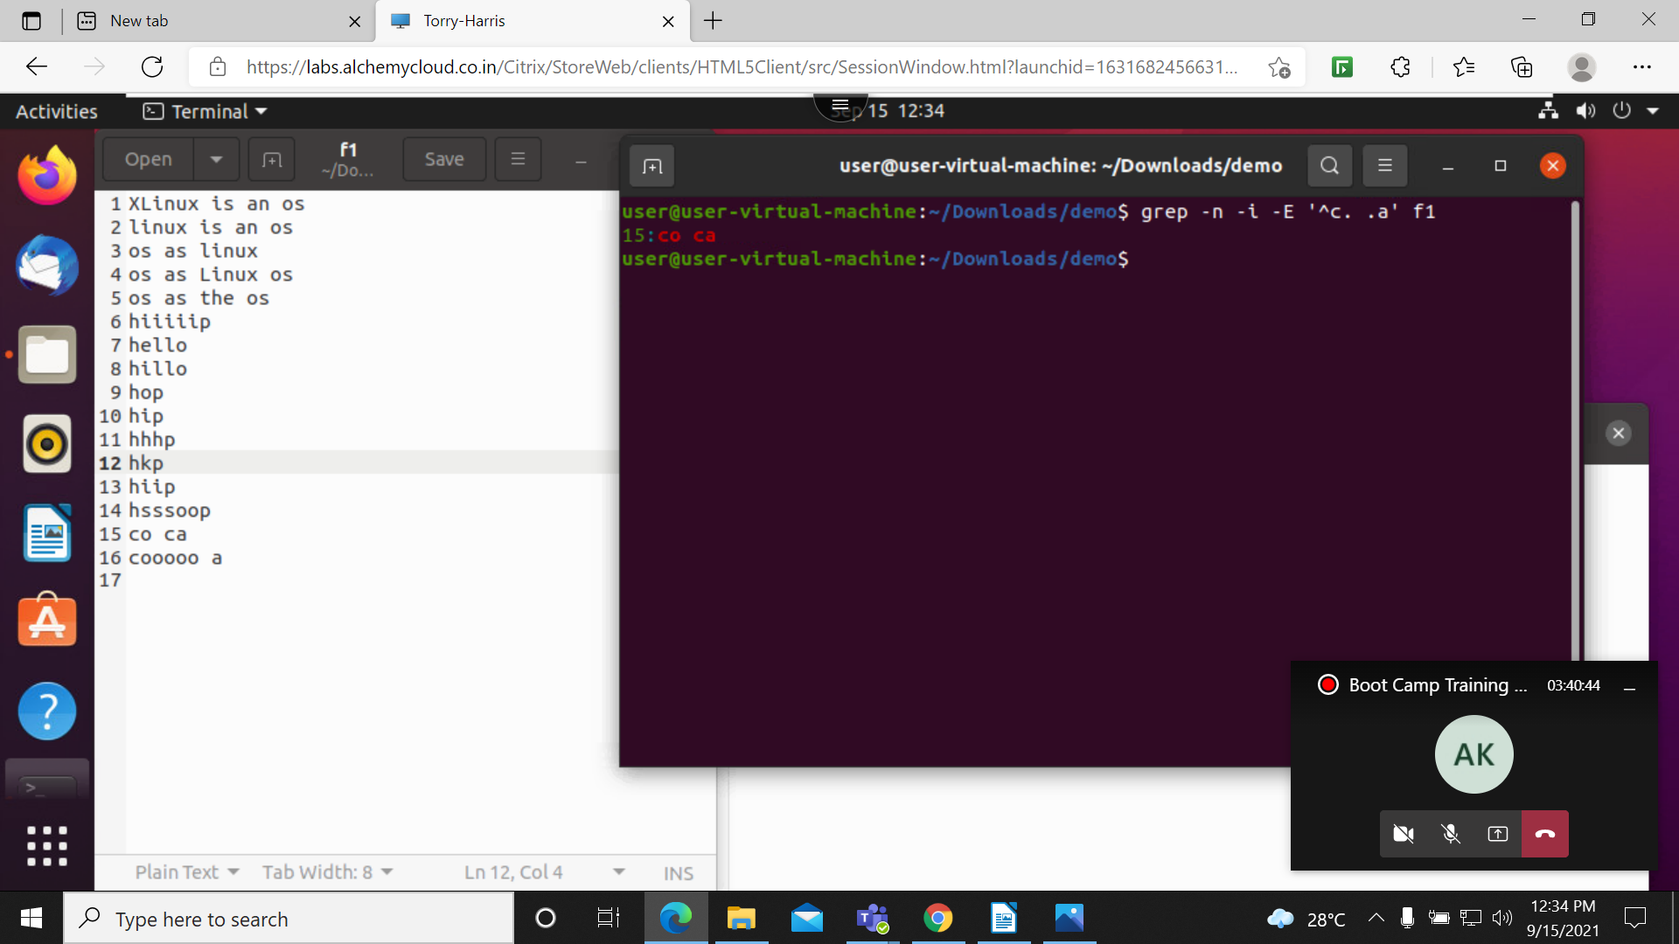
24. grep -n -i -E ‘c. .a’ f1: this will print the space between the character all those strings

25. grep -n -i -E ‘^h[^i].*o$: this will print all the strings wich does not contain I character
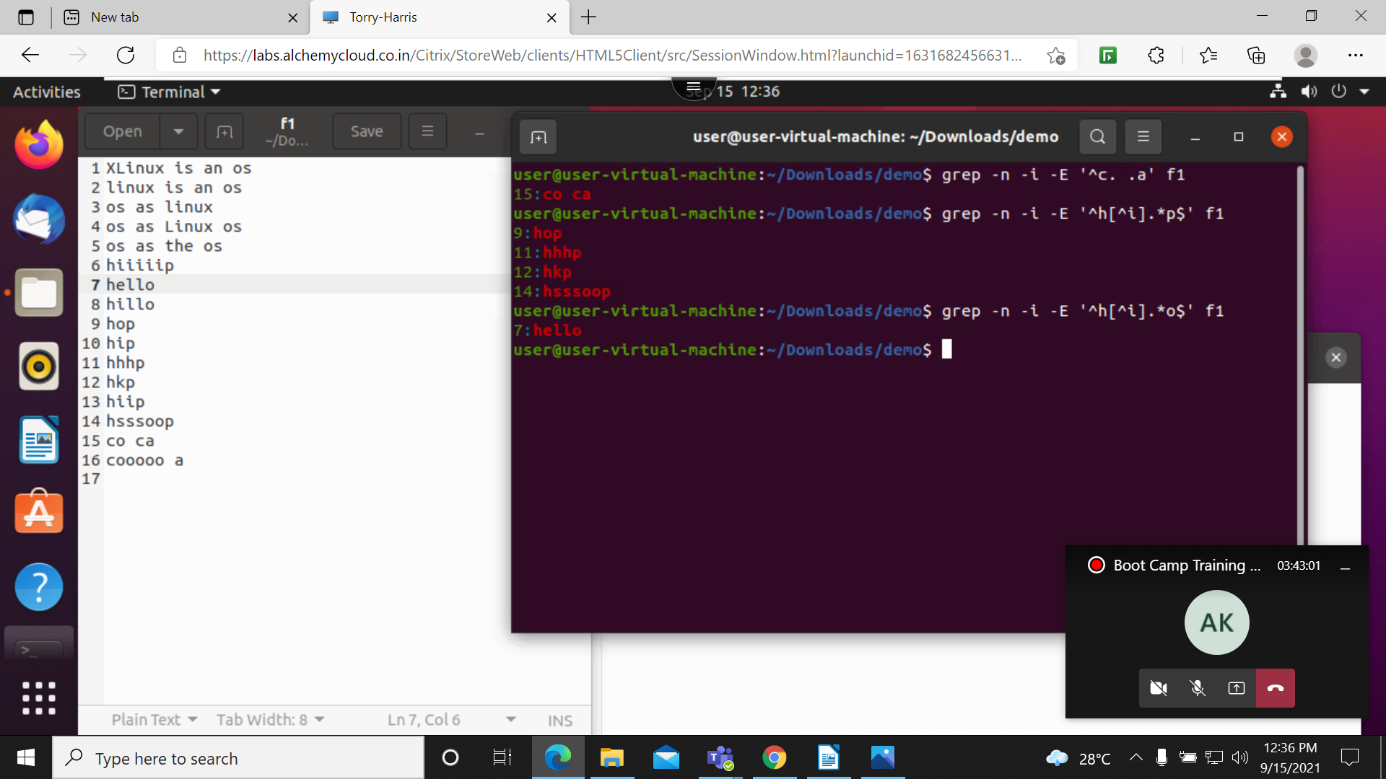

26. grep -n -i -E ‘^h.*[i].*p$: it will give all the strings except I
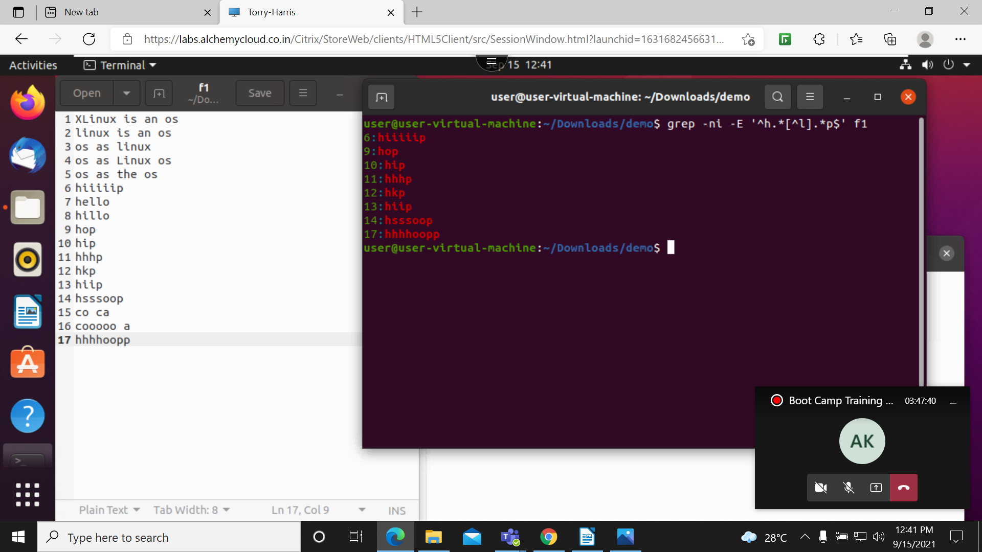

27. grep -n -i -E ‘^[a-z].*$’: this will print all strings from a to z
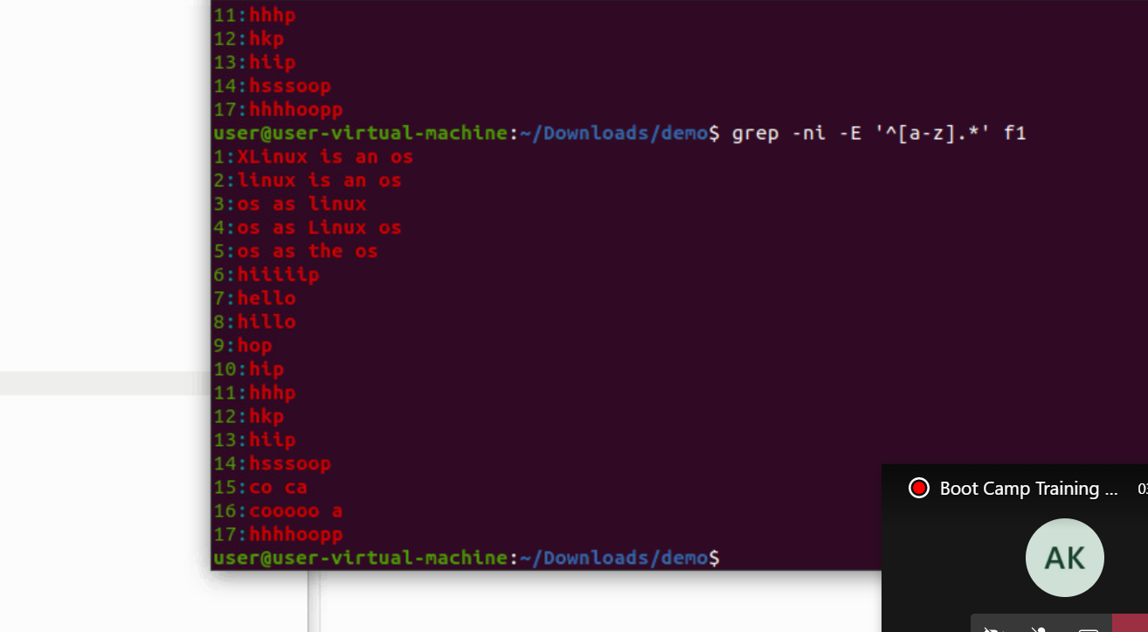

28. grep -n -i -E ‘^\[\]$’: this will print all the strings with is ending with [] braces
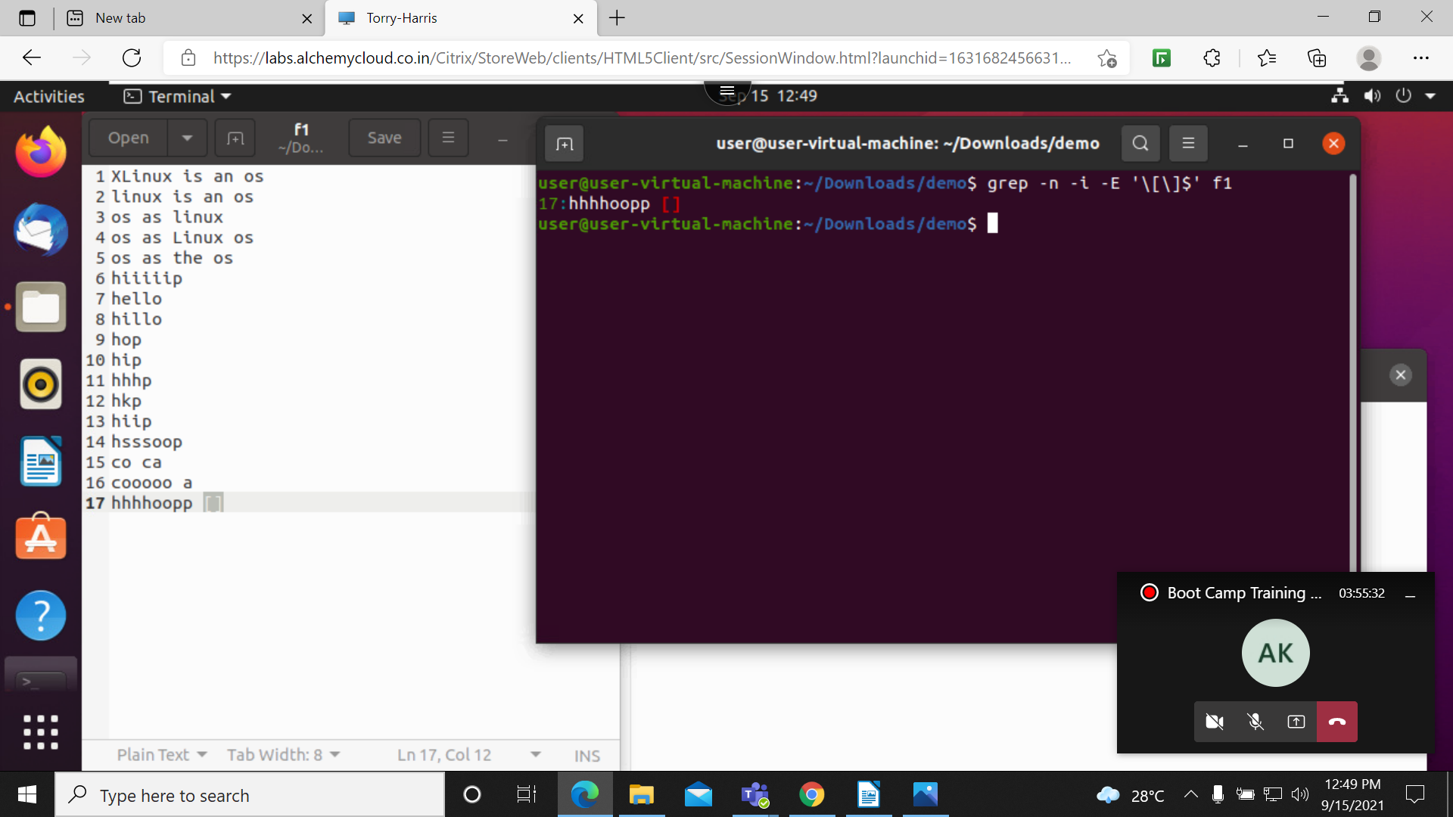

29. cut -c 1 f1: this command used to cut the section of each line of file


